Steps to run project:

1. Extract CollegeSelection.zip to desired location.
2. Import to XAMP the database file collegeSelectionDB.sql
3. In code change the JDBC connection username and password with your XAMP or database credentials

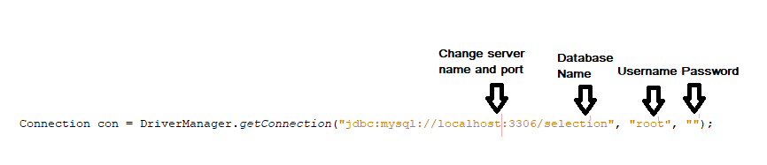

1. Keep the database name as “**selection**” and import the .sql file
2. Add this file **mysql-connector-java-5.1.13-bin** to libraries folder of project.

Features:

1. Candidates can log in priority wise based on their ranks.
2. Once candidate selects his desired college and course he cannot log in and change his selection.
3. One Candidate can select only one course and that course cannot be selected by other candidate

Database Tables:

Login Table

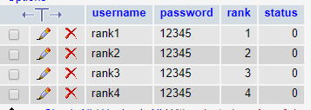

College Details Table

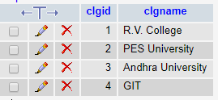

Course Details Table

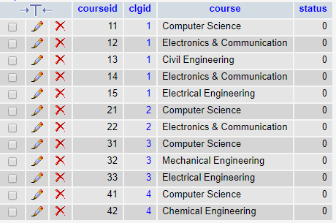

Result:

